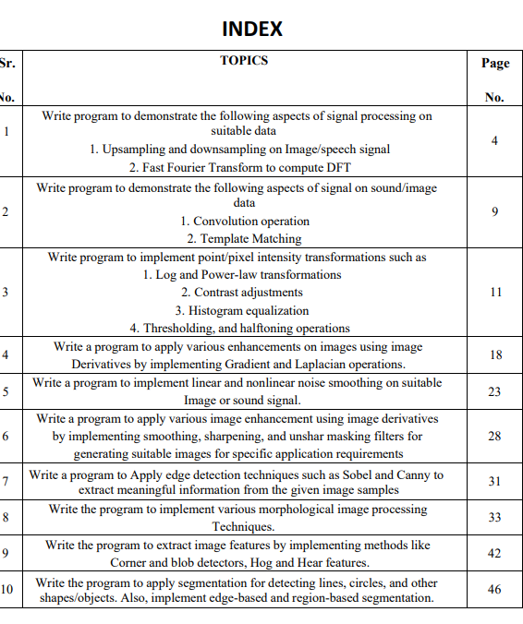

PRACTICAL NO. 1

A:UNSAMPLING ANS SAMPLING OF AN IMAGE.

import cv2

# Load an image

image = cv2.imread("C:\PALLAVI WORK\MSC CS PART 1 IMAGE PROCESSING\practicals\sample1.jpg")

# Display the original image

cv2.imshow('Original Image', image)

cv2.waitKey(0)

#cv2.destroyAllWindows()

# Perform downsampling

scale_factor = 0.5 # For example, to downsample by 2

downsampled_image = cv2.resize(image, None, fx=scale_factor, fy=scale_factor, interpolation=cv2.INTER_LINEAR)

# Display the downsampled image

cv2.imshow('Downsampled Image', downsampled_image)

cv2.waitKey(0)

#cv2.destroyAllWindows()

# Perform upsampling

scale_factor = 2 # For example, to upsample by 2

upsampled_image = cv2.resize(image, None, fx=scale_factor, fy=scale_factor, interpolation=cv2.INTER_LINEAR)

# Display the upsampled image

cv2.imshow('Upsampled Image', upsampled_image)

cv2.waitKey(0)

#cv2.destroyAllWindows()

**Output**

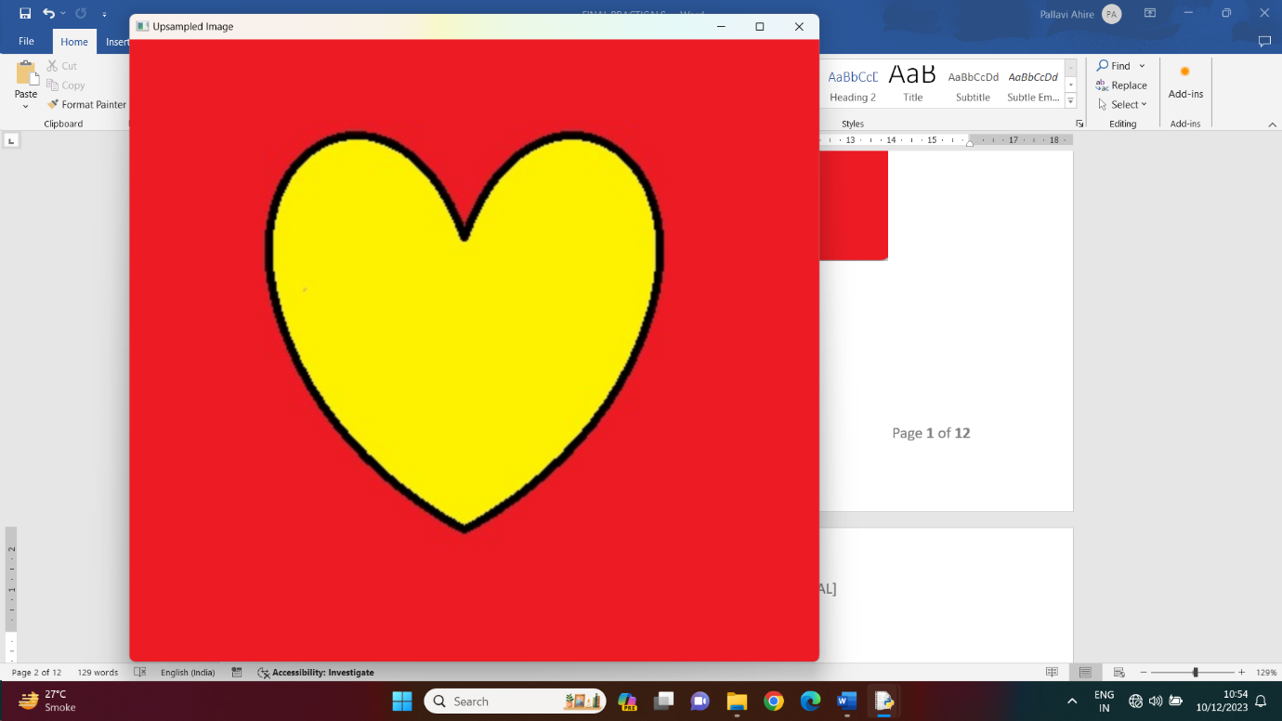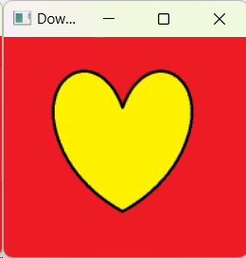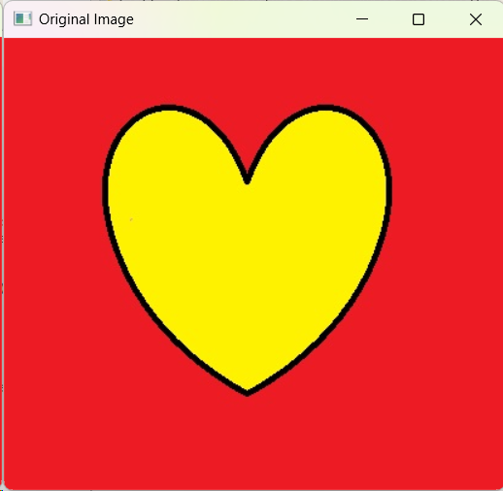

**Practical no. 1 b : Fast Fourier Transform to compute DFT**

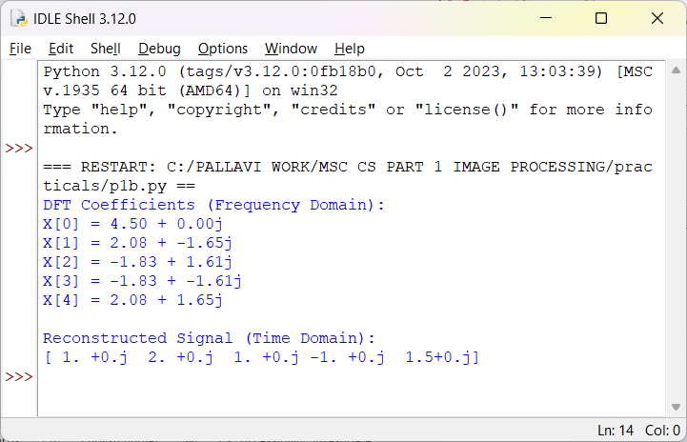code:

import numpy as np

# Sample data (time domain signal)

x = np.array([1.0, 2.0, 1.0, -1.0, 1.5])

# Compute the FFT

X = np.fft.fft(x)

# Print the result

print("DFT Coefficients (Frequency Domain):")

for i, value in enumerate(X):

print(f"X[{i}] = {value.real:.2f} + {value.imag:.2f}j")

# Compute the inverse FFT (iFFT) to obtain the original signal (optional)

x_reconstructed = np.fft.ifft(X)

print("\nReconstructed Signal (Time Domain):")

print(x_reconstructed)

output:

**PRACTICAL NO. 2 A: Create a triangle signal and plot a 3-period segment**

CODE:

import numpy as np

import matplotlib.pyplot as plt

def triangle_wave(periods, points_per_period, amplitude=1.0):

t = np.linspace(0, 2 * np.pi * periods, periods * points_per_period, endpoint=False)

signal = amplitude * (2 * np.abs((t / (2 * np.pi)) - 0.5) - 1)

return t, signal

# Parameters

periods = 3

points_per_period = 1000

# Generate triangle wave

t, signal = triangle_wave(periods, points_per_period)

# Plotting

plt.plot(t, signal, label='Triangle Wave')

plt.title('Triangle Wave - 3 Periods')

plt.xlabel('Time')

plt.ylabel('Amplitude')

plt.legend()

plt.grid(True)

plt.show()

OUTPUT:

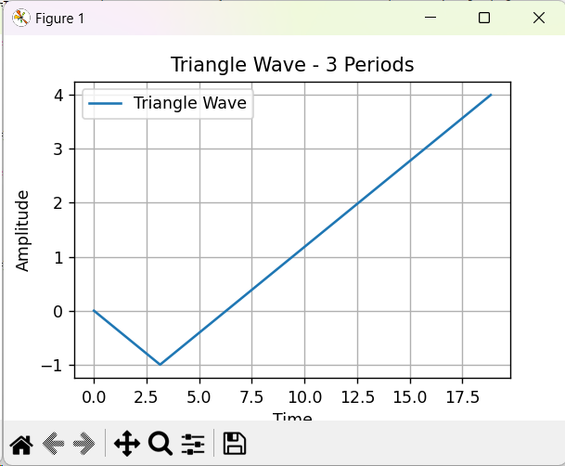

**PRACTICAL NO. 2 B : For a given signal, plot the segment and compute the correlation between them.**

CODE:

import numpy as np

import matplotlib.pyplot as plt

def plot_and_correlate(signal1, signal2, segment_length):

# Plotting the signals

plt.figure(figsize=(10, 4))

plt.subplot(2, 1, 1)

plt.plot(signal1, label='Signal 1')

plt.plot(signal2, label='Signal 2')

plt.title('Signals')

plt.legend()

# Computing correlation between segments

correlation_values = []

for i in range(len(signal1) - segment_length + 1):

segment1 = signal1[i:i+segment_length]

segment2 = signal2[i:i+segment_length]

correlation = np.correlate(segment1, segment2)

correlation_values.append(correlation)

# Plotting the correlation values

plt.subplot(2, 1, 2)

plt.plot(correlation_values, label='Correlation')

plt.title('Correlation between segments')

plt.legend()

plt.tight_layout()

plt.show()

# Example usage

if __name__ == "__main__":

# Generate example signals

np.random.seed(42)

signal_length = 100

segment_length = 10

signal1 = np.random.randn(signal_length)

signal2 = np.roll(signal1, shift=5) # Shifted version of signal1

# Call the function to plot and compute correlation

plot_and_correlate(signal1, signal2, segment_length)

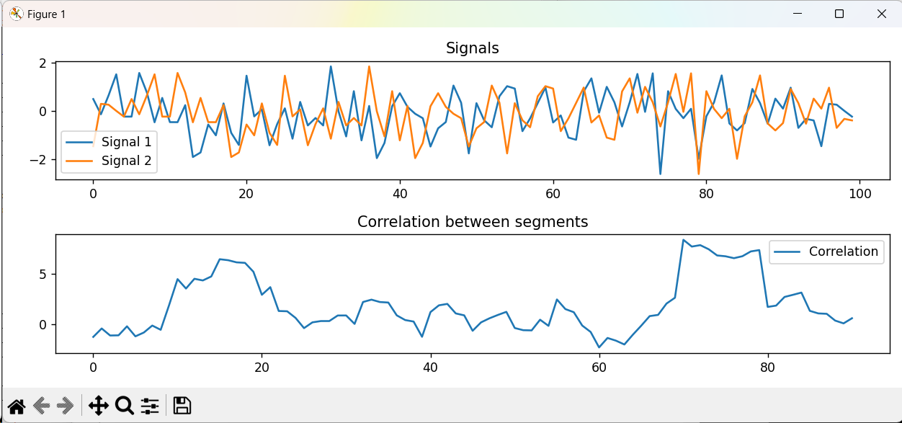OUTPUT :

**PRACTICAL NO. 3 A: Write program to demonstrate the following aspects of signal on sound/image data**

1. Convolution operation

Code:

import numpy as np

import matplotlib.pyplot as plt

from scipy import signal

from scipy import ndimage

from skimage import data

def convolve_image(input_image, kernel):

# Read the input image

image = data.camera() # You can replace this with your own image data

# Convolve the image with the kernel using scipy's convolve2d

convolved_image = signal.convolve2d(image, kernel, mode='same', boundary='symm')

# Plot the original and convolved image

plt.figure(figsize=(10, 4))

plt.subplot(1, 2, 1)

plt.imshow(image, cmap='gray')

plt.title('Original Image')

plt.subplot(1, 2, 2)

plt.imshow(convolved_image, cmap='gray')

plt.title('Convolved Image')

plt.tight_layout()

plt.show()

# Example usage

if __name__ == "__main__":

# Create a simple 3x3 kernel

kernel = np.array([[1, 0, -1],

[2, 0, -2],

[1, 0, -1]])

# Convolve the image with the kernel

convolve_image('input_image.jpg', kernel)

output:

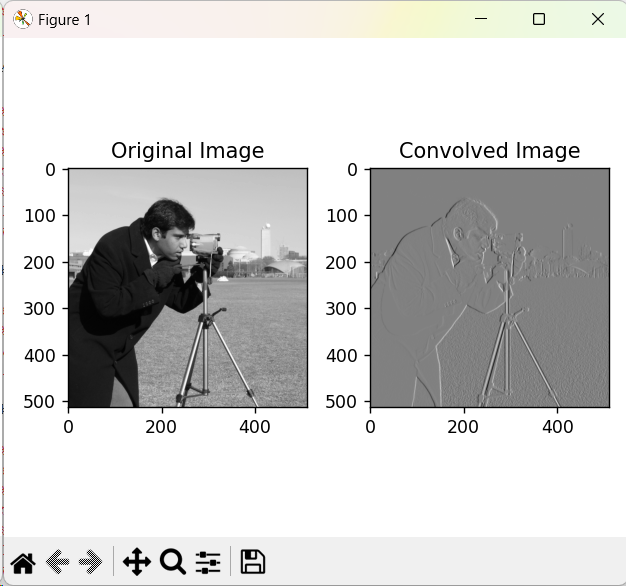

**PRACTICAL NO. 3 B : Template Matching**

Code:

import numpy as np

import matplotlib.pyplot as plt

from skimage import data

from skimage.feature import match_template

def template_matching_image(image, template):

result = match_template(image, template)

ij = np.unravel_index(np.argmax(result), result.shape)

x, y = ij[::-1]

# Plot the original image and the template match

plt.figure(figsize=(8, 4))

plt.subplot(1, 2, 1)

plt.imshow(image, cmap='gray')

plt.title('Original Image')

plt.subplot(1, 2, 2)

plt.imshow(template, cmap='gray')

plt.title('Template')

plt.show()

# Highlight the matched region

fig, ax = plt.subplots()

ax.imshow(image, cmap='gray')

ax.set_title('Template Matching Result')

rect = plt.Rectangle((x, y), template.shape[1], template.shape[0], edgecolor='r', facecolor='none')

ax.add_patch(rect)

plt.show()

# Example usage

if __name__ == "__main__":

# Load example image and template

image = data.camera()

template = image[20:70, 150:200] # Sample template from the image

# Perform template matching

template_matching_image(image, template)

Output:

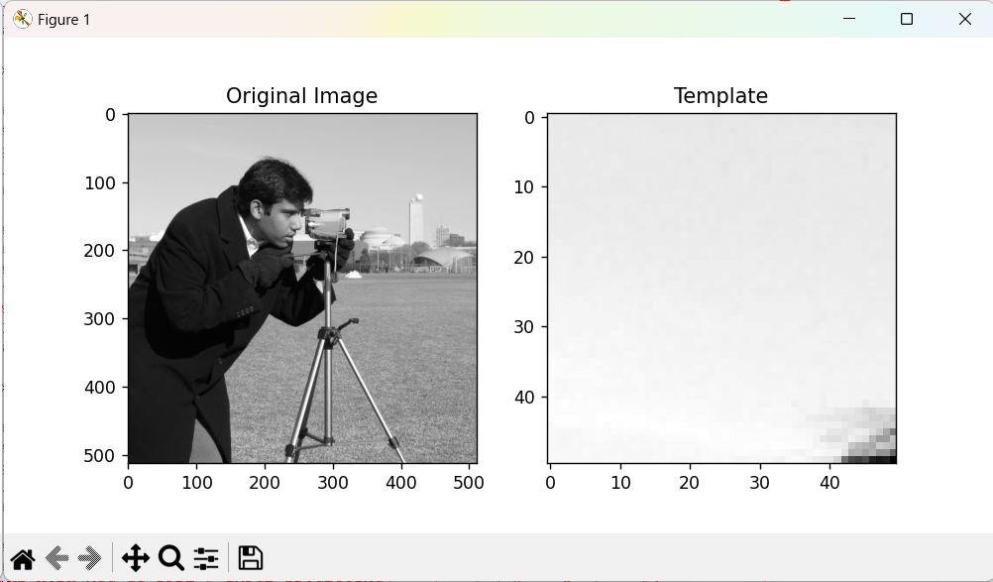

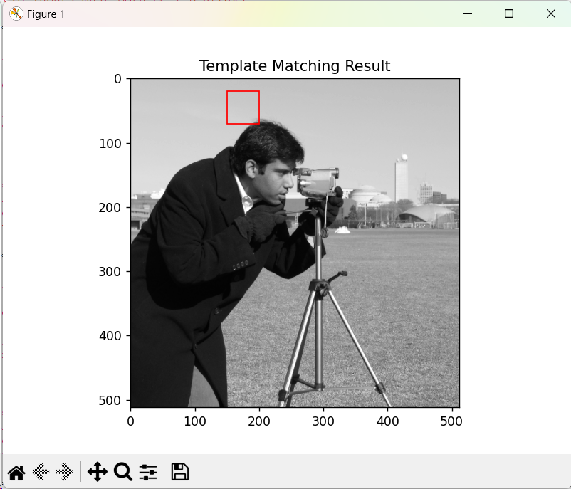

**PRACTICAL NO. 4 A:**

**Write program to implement point/pixel intensity transformations such as**

1. **Log and Power-law transformations**

import cv2

import numpy as np

# Load the image

img = cv2.imread('C:/images/forest.JPG')

# Apply log transform

img_log = (np.log(img+1)/(np.log(1+np.max(img))))*255

# Specify the data type

img_log = np.array(img_log,dtype=np.uint8)

# Display the image

cv2.imshow('log_image',img_log )

cv2.imshow('original_img',img)

cv2.waitKey(0)

log image

Original image

Log transform output with 1st as original image and second one is log transformation image.

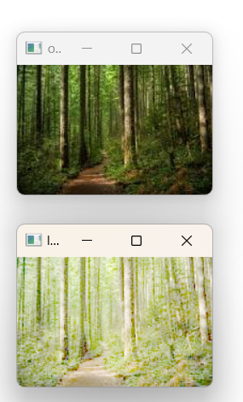

**gamma transformation .power law**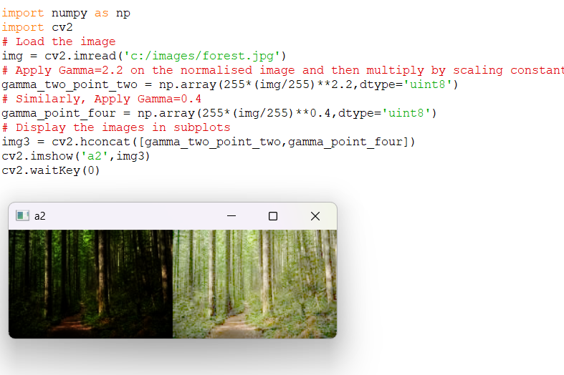

**4 b : contrast adjustment**

import cv2

import numpy as np

def adjust_contrast(image, alpha, beta):

"""

Adjusts the contrast of an image using the formula: output = alpha * input + beta

"""

adjusted_image = cv2.convertScaleAbs(image, alpha=alpha, beta=beta)

return adjusted_image

# Read an image from file

input_image_path = "C:\PALLAVI WORK\MSC CS PART 1 IMAGE PROCESSING\practicals\sample.jpg"

original_image = cv2.imread(input_image_path)

# Define contrast adjustment parameters

contrast_alpha = 1.5 # Increase for higher contrast, decrease for lower contrast

contrast_beta = 30 # Adjust the brightness

# Adjust the contrast of the image

contrast_adjusted_image = adjust_contrast(original_image, alpha=contrast_alpha, beta=contrast_beta)

# Display the original and adjusted images

cv2.imshow('Original Image', original_image)

cv2.imshow('Contrast Adjusted Image', contrast_adjusted_image)

cv2.waitKey(0)

cv2.destroyAllWindows()

Output:

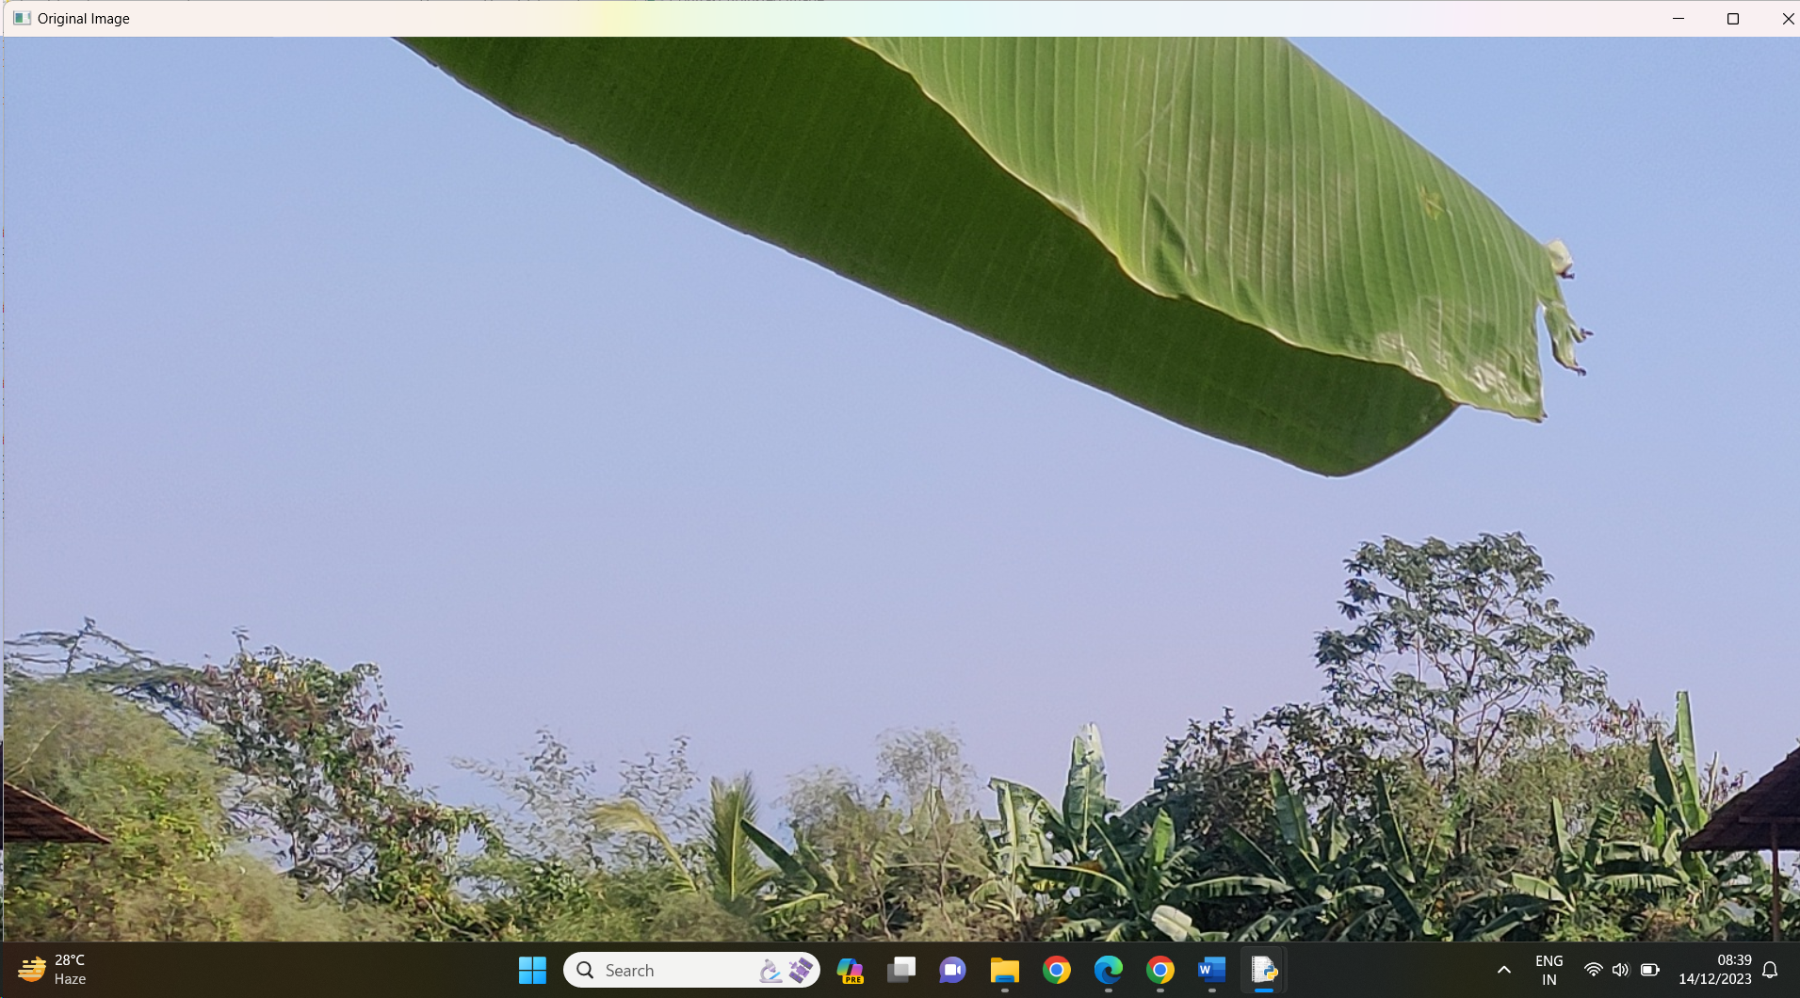

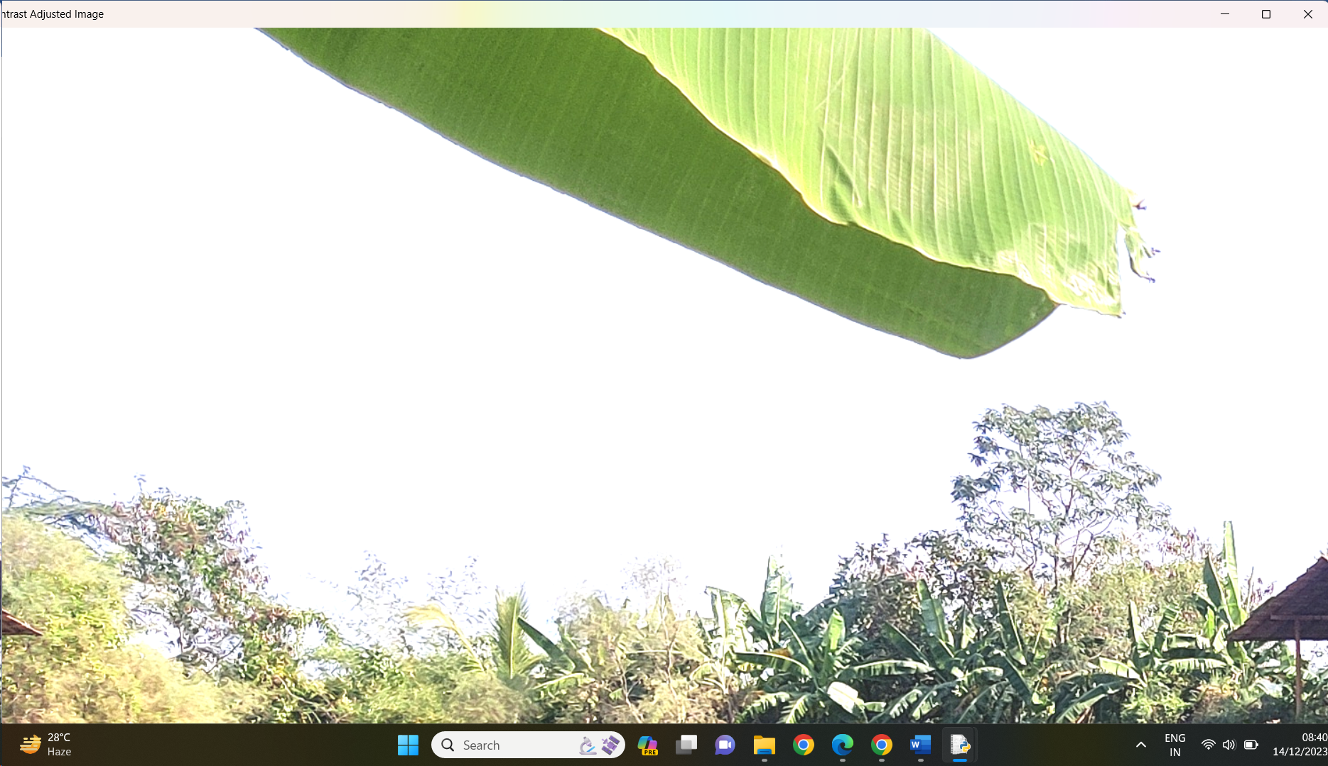

1st original image 2nd contrast image

**4 c: Histogram equalization**

import cv2

import numpy as np

import matplotlib.pyplot as plt

def apply_threshold(image_path, threshold_value):

# Read the image in grayscale

img = cv2.imread(image_path, cv2.IMREAD_GRAYSCALE)

# Apply thresholding

_, thresholded_img = cv2.threshold(img, threshold_value, 255, cv2.THRESH_BINARY)

# Display the original and thresholded images

plt.figure(figsize=(10, 5))

plt.subplot(1, 2, 1)

plt.imshow(img, cmap='gray')

plt.title('Original Image')

plt.subplot(1, 2, 2)

plt.imshow(thresholded_img, cmap='gray')

plt.title('Thresholded Image')

plt.show()

# Save the thresholded image if needed

cv2.imwrite('thresholded_image.jpg', thresholded_img)

# Replace 'path/to/your/image.jpg' with the actual path to your image file

image_path = "C:\PALLAVI WORK\MSC CS PART 1 IMAGE PROCESSING\practicals\sample.jpg"

threshold_value = 127 # Adjust this value as needed

apply_threshold(image_path, threshold_value)

Output: as follow

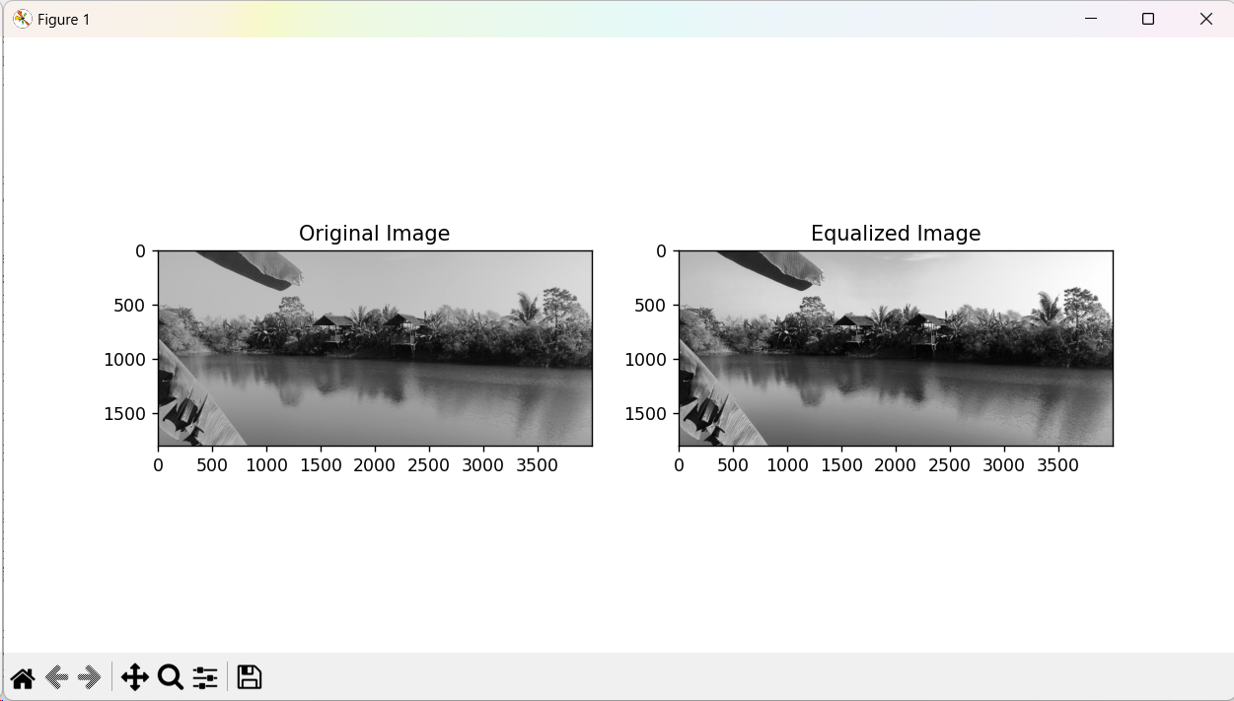

**4d: thresholding operation**

import cv2

import numpy as np

import matplotlib.pyplot as plt

def apply_threshold(image_path, threshold_value):

# Read the image in grayscale

img = cv2.imread(image_path, cv2.IMREAD_GRAYSCALE)

# Apply thresholding

_, thresholded_img = cv2.threshold(img, threshold_value, 255, cv2.THRESH_BINARY)

# Display the original and thresholded images

plt.figure(figsize=(10, 5))

plt.subplot(1, 2, 1)

plt.imshow(img, cmap='gray')

plt.title('Original Image')

plt.subplot(1, 2, 2)

plt.imshow(thresholded_img, cmap='gray')

plt.title('Thresholded Image')

plt.show()

# Save the thresholded image if needed

cv2.imwrite('thresholded_image.jpg', thresholded_img)

# Replace 'path/to/your/image.jpg' with the actual path to your image file

image_path = "C:\PALLAVI WORK\MSC CS PART 1 IMAGE PROCESSING\practicals\sample.jpg"

threshold_value = 127 # Adjust this value as needed

apply_threshold(image_path, threshold_value)

Output:

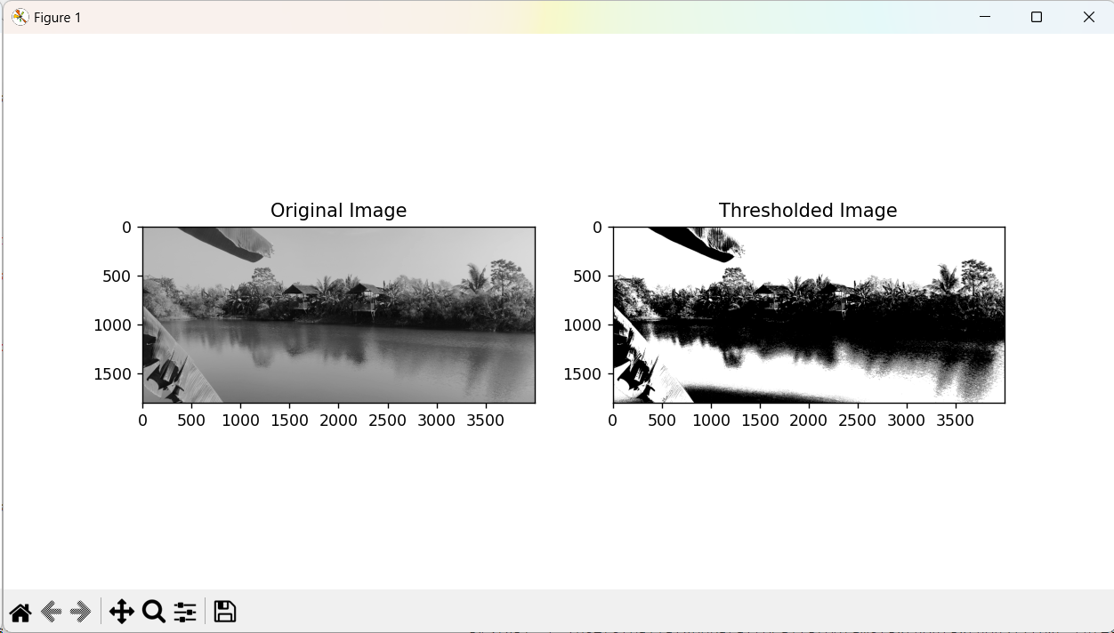

**4d: halftoning**

import cv2

import numpy as np

import matplotlib.pyplot as plt

def halftone(image_path):

# Read the image in grayscale

img = cv2.imread(image_path, cv2.IMREAD_GRAYSCALE)

# Convert image to binary using dithering

_, binary_img = cv2.threshold(img, 128, 255, cv2.THRESH_BINARY)

# Display the original and halftone images

plt.figure(figsize=(10, 5))

plt.subplot(1, 2, 1)

plt.imshow(img, cmap='gray')

plt.title('Original Image')

plt.subplot(1, 2, 2)

plt.imshow(binary_img, cmap='gray')

plt.title('Halftone Image')

plt.show()

# Save the halftone image if needed

cv2.imwrite('halftone_image.jpg', binary_img)

# Replace 'path/to/your/image.jpg' with the actual path to your image file

image_path = "C:\PALLAVI WORK\MSC CS PART 1 IMAGE PROCESSING\practicals\sample.jpg"

halftone(image_path)

output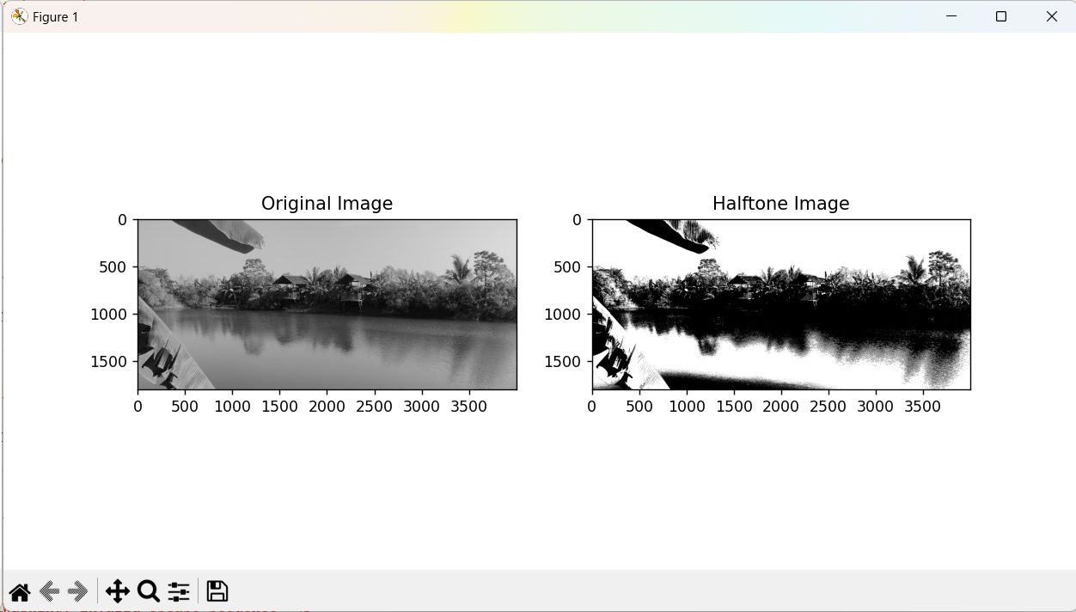

**Practical 5:**

**Write a program to apply various enhancements on images using image derivatives by implementing Gradient and Laplacian operations.**

import cv2

import numpy as np

import matplotlib.pyplot as plt

# Load the image

image = cv2.imread('image.jpg', cv2.IMREAD_GRAYSCALE)

# Apply the Sobel operator to compute gradients

sobel_x = cv2.Sobel(image, cv2.CV_64F, 1, 0, ksize=3)

sobel_y = cv2.Sobel(image, cv2.CV_64F, 0, 1, ksize=3)

# Compute the magnitude of gradients

gradient_magnitude = np.sqrt(sobel_x**2 + sobel_y**2)

laplacian = cv2.Laplacian(image, cv2.CV_64F) # apply Laplacian operator

plt.figure(figsize=(12, 6)) # Plotting

plt.subplot(2, 2, 1)

plt.imshow(image, cmap='gray')

plt.title('Original Image')

plt.subplot(2, 2, 2)

plt.imshow(gradient_magnitude, cmap='gray')

plt.title('Gradient Magnitude')

plt.subplot(2, 2, 3)

plt.imshow(sobel_x, cmap='gray')

plt.title('Sobel X')

plt.subplot(2, 2, 4)

plt.imshow(sobel_y, cmap='gray')

plt.title('Sobel Y')

plt.figure(figsize=(6, 6))

plt.imshow(laplacian, cmap='gray')

plt.title('Laplacian')

plt.show()

practical no 6:

Write a program to apply various enhancements on images using image derivatives by implementing Gradient and Laplacian operations

Code:

import cv2

import numpy as np

import matplotlib.pyplot as plt

def apply_gradient_laplacian(image_path):

# Read the image in grayscale

img = cv2.imread(image_path, cv2.IMREAD_GRAYSCALE)

# Apply the Sobel operator to calculate gradients

gradient_x = cv2.Sobel(img, cv2.CV_64F, 1, 0, ksize=3)

gradient_y = cv2.Sobel(img, cv2.CV_64F, 0, 1, ksize=3)

# Calculate magnitude and direction of the gradients

gradient_magnitude = np.sqrt(gradient_x**2 + gradient_y**2)

gradient_direction = np.arctan2(gradient_y, gradient_x)

# Apply Laplacian operator

laplacian = cv2.Laplacian(img, cv2.CV_64F)

# Display the original, gradient, and Laplacian images

plt.figure(figsize=(15, 5))

plt.subplot(1, 3, 1)

plt.imshow(img, cmap='gray')

plt.title('Original Image')

plt.subplot(1, 3, 2)

plt.imshow(gradient_magnitude, cmap='viridis')

plt.title('Gradient Magnitude')

plt.subplot(1, 3, 3)

plt.imshow(laplacian, cmap='coolwarm')

plt.title('Laplacian Image')

plt.show()

# Save the gradient magnitude and Laplacian images if needed

cv2.imwrite('gradient_magnitude.jpg', gradient_magnitude)

cv2.imwrite('laplacian_image.jpg', laplacian)

image_path = "C:\PALLAVI WORK\MSC CS PART 1 IMAGE PROCESSING\practicals\sample.jpg"

apply_gradient_laplacian(image_path)

output:

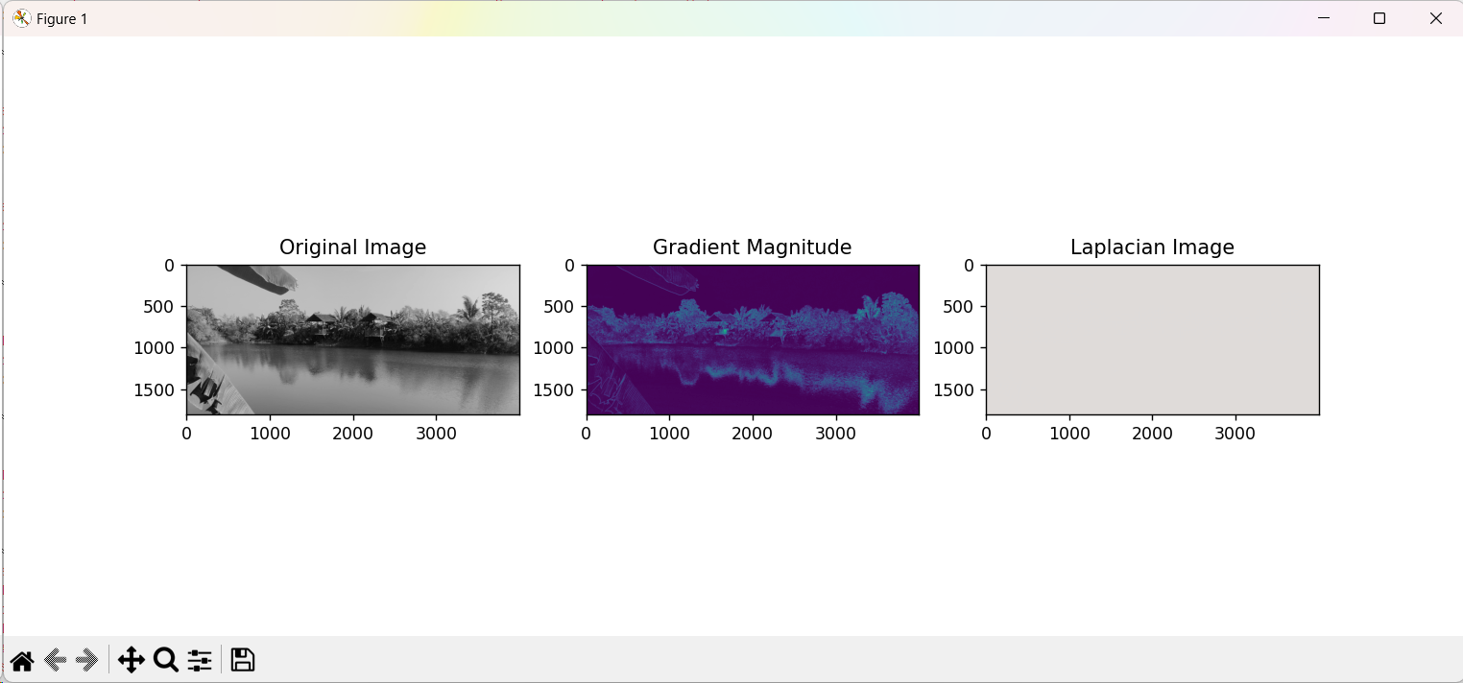

**Practical no. 7: Write a program to apply various image enhancement using image derivatives by implementing smoothing, sharpening, and unsharp masking filters for generating suitable images for specific application requirements**

**# Image smoothening**

Code:

import cv2

import numpy as np

from matplotlib import pyplot as plt

def apply_gaussian_blur(image_path, kernel_size=(5, 5)):

# Read the image

image = cv2.imread(image_path)

# Convert the image to RGB (OpenCV uses BGR by default)

image_rgb = cv2.cvtColor(image, cv2.COLOR_BGR2RGB)

# Apply Gaussian blur

smoothed_image = cv2.GaussianBlur(image_rgb, kernel_size, 0)

# Display the original and smoothed images

plt.figure(figsize=(10, 5))

plt.subplot(1, 2, 1)

plt.imshow(image_rgb)

plt.title('Original Image')

plt.subplot(1, 2, 2)

plt.imshow(smoothed_image)

plt.title('Smoothed Image')

plt.show()

return smoothed_image

image_path = "C:\PALLAVI WORK\MSC CS PART 1 IMAGE PROCESSING\practicals\sample.jpg"

smoothed_image = apply_gaussian_blur(image_path, kernel_size=(5, 5))

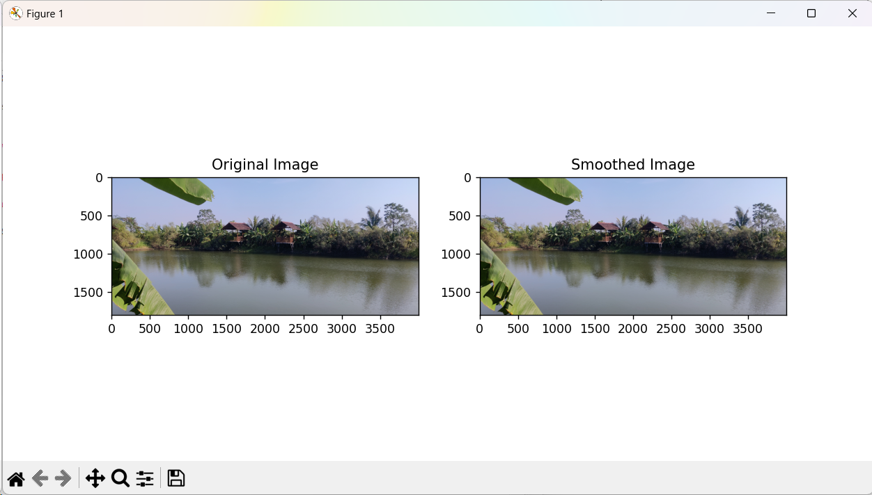

**Practical 7 : image sharpening**

**Code**:

import cv2

import numpy as np

from matplotlib import pyplot as plt

def apply_unsharp_mask(image_path, sigma=1.5, strength=1.5):

# Read the image

image = cv2.imread(image_path)

# Convert the image to grayscale

grayscale_image = cv2.cvtColor(image, cv2.COLOR_BGR2GRAY)

# Apply Gaussian blur

blurred_image = cv2.GaussianBlur(grayscale_image, (0, 0), sigma)

# Calculate the unsharp mask

unsharp_mask = grayscale_image - blurred_image

# Enhance the edges with the unsharp mask

sharpened_image = grayscale_image + strength * unsharp_mask

# Clip values to the valid range [0, 255]

sharpened_image = np.clip(sharpened_image, 0, 255)

# Display the original and sharpened images

plt.figure(figsize=(10, 5))

plt.subplot(1, 2, 1)

plt.imshow(grayscale_image, cmap='gray')

plt.title('Original Image')

plt.subplot(1, 2, 2)

plt.imshow(sharpened_image, cmap='gray')

plt.title('Sharpened Image')

plt.show()

return sharpened_image

image_path = "C:\PALLAVI WORK\MSC CS PART 1 IMAGE PROCESSING\practicals\sample.jpg"

sharpened_image = apply_unsharp_mask(image_path, sigma=1.5, strength=1.5)

Output:

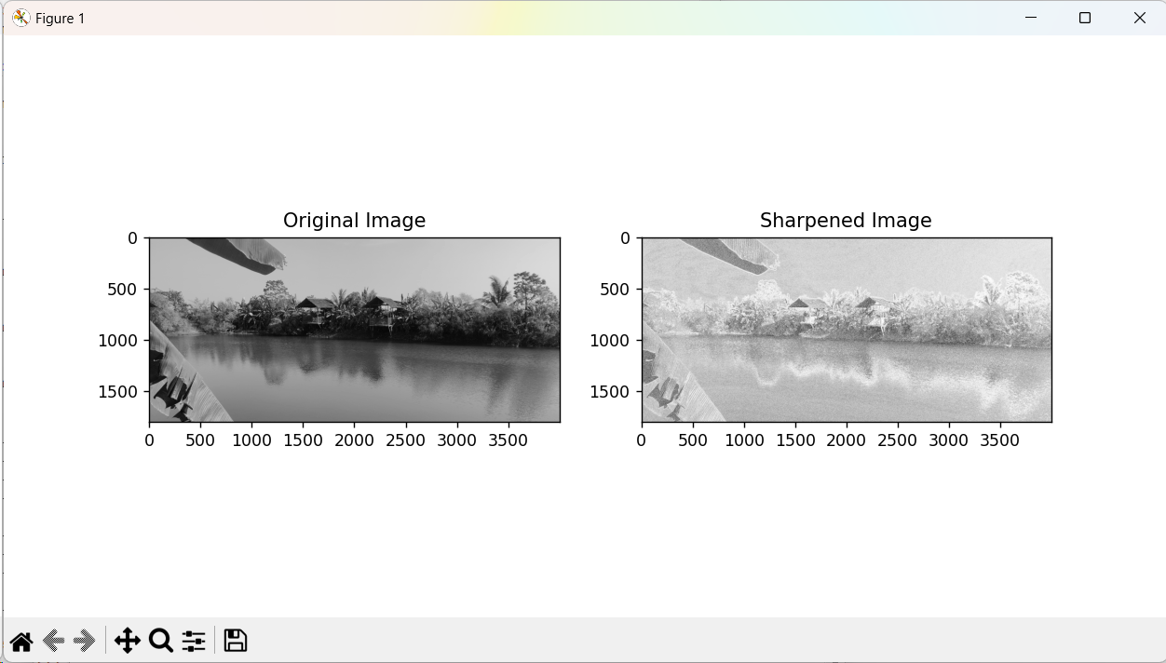

**Practical 7 : unsharp an image / blurring of an image.**

**Code:**

import cv2

import numpy as np

from matplotlib import pyplot as plt

def unsharp_masking(image_path, sigma=1.5, strength=1.5):

# Read the image

image = cv2.imread(image_path)

# Convert the image to grayscale

grayscale_image = cv2.cvtColor(image, cv2.COLOR_BGR2GRAY)

# Apply Gaussian blur

blurred_image = cv2.GaussianBlur(grayscale_image, (0, 0), sigma)

# Create a sharpening kernel

kernel = np.array([[-1, -1, -1],

[-1, 9, -1],

[-1, -1, -1]])

# Apply the sharpening kernel

sharpened_image = cv2.filter2D(blurred_image, -1, kernel)

# Enhance the edges with the unsharp mask

sharpened_image = grayscale_image + strength * (grayscale_image - sharpened_image)

# Clip values to the valid range [0, 255]

sharpened_image = np.clip(sharpened_image, 0, 255)

# Display the original, blurred, and sharpened images

plt.figure(figsize=(15, 5))

plt.subplot(1, 3, 1)

plt.imshow(grayscale_image, cmap='gray')

plt.title('Original Image')

plt.subplot(1, 3, 2)

plt.imshow(blurred_image, cmap='gray')

plt.title('Blurred Image')

plt.subplot(1, 3, 3)

plt.imshow(sharpened_image, cmap='gray')

plt.title('Sharpened Image')

plt.show()

return sharpened_image

image_path = "C:\PALLAVI WORK\MSC CS PART 1 IMAGE PROCESSING\practicals\sample.jpg"

sharpened_image = unsharp_masking(image_path, sigma=1.5, strength=1.5)

Output:

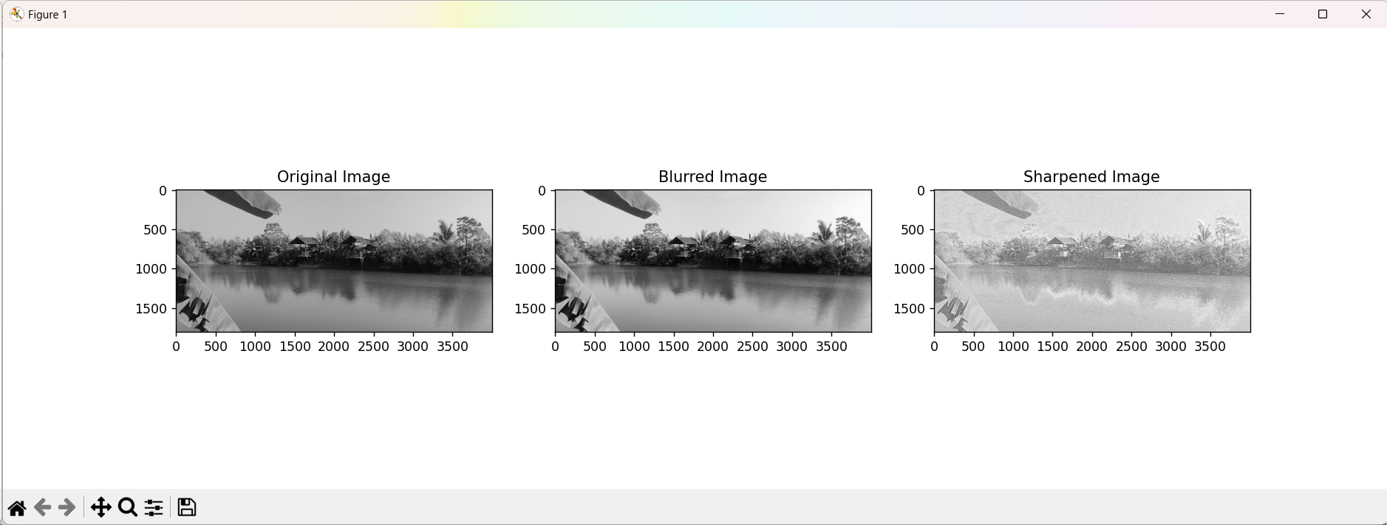

**Practical 8 :**

**write a program to Apply edge detection techniques such as Sobel and Canny to extract meaningful information from the given image samples**

Code:

import cv2

import numpy as np

import matplotlib.pyplot as plt

def apply_sobel(image):

# Convert the image to grayscale

gray = cv2.cvtColor(image, cv2.COLOR_BGR2GRAY)

# Apply Sobel operator to find edges

sobel_x = cv2.Sobel(gray, cv2.CV_64F, 1, 0, ksize=3)

sobel_y = cv2.Sobel(gray, cv2.CV_64F, 0, 1, ksize=3)

# Calculate the gradient magnitude

gradient_magnitude = np.sqrt(sobel_x**2 + sobel_y**2)

# Normalize the gradient magnitude to the range [0, 255]

gradient_magnitude = np.uint8(255 * gradient_magnitude / np.max(gradient_magnitude))

return gradient_magnitude

def apply_canny(image):

# Convert the image to grayscale

gray = cv2.cvtColor(image, cv2.COLOR_BGR2GRAY)

# Apply Gaussian blur to reduce noise

blurred = cv2.GaussianBlur(gray, (5, 5), 0)

# Apply Canny edge detection

edges = cv2.Canny(blurred, 50, 150)

return edges

def main():

# Load the image

image_path = "C:\PALLAVI WORK\MSC CS PART 1 IMAGE PROCESSING\practicals\sample.jpg"

image = cv2.imread(image_path)

if image is None:

print(f"Error: Unable to read the image from {image_path}")

return

# Apply Sobel edge detection

sobel_result = apply_sobel(image)

# Apply Canny edge detection

canny_result = apply_canny(image)

# Display the original image and the results

plt.figure(figsize=(10, 5))

plt.subplot(131)

plt.imshow(cv2.cvtColor(image, cv2.COLOR_BGR2RGB))

plt.title('Original Image')

plt.subplot(132)

plt.imshow(sobel_result, cmap='gray')

plt.title('Sobel Edge Detection')

plt.subplot(133)

plt.imshow(canny_result, cmap='gray')

plt.title('Canny Edge Detection')

plt.show()

if __name__ == "__main__":

main()

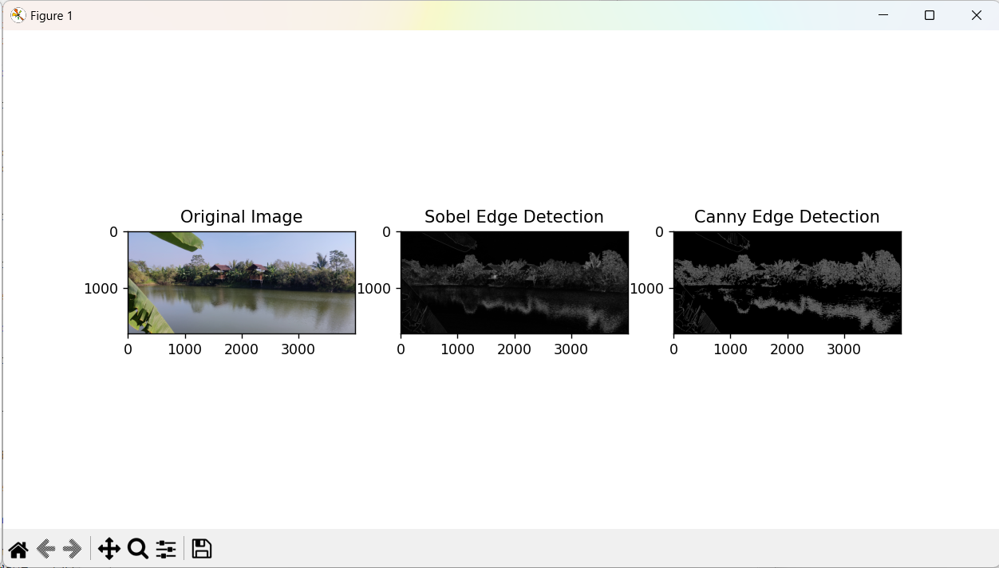

**Practical 9:**

**Write the program to implement various morphological image processing techniques**.

Code:

import cv2

import numpy as np

import matplotlib.pyplot as plt

def apply_morphological_operations(image_path):

# Read the image

image = cv2.imread(image_path, cv2.IMREAD_GRAYSCALE)

if image is None:

print(f"Error: Unable to read the image from {image_path}")

return

# Display the original image

plt.figure(figsize=(10, 4))

plt.subplot(131)

plt.imshow(image, cmap='gray')

plt.title('Original Image')

# Erosion

kernel = np.ones((5, 5), np.uint8)

erosion = cv2.erode(image, kernel, iterations=1)

# Display the eroded image

plt.subplot(132)

plt.imshow(erosion, cmap='gray')

plt.title('Erosion')

# Dilation

dilation = cv2.dilate(image, kernel, iterations=1)

# Display the dilated image

plt.subplot(133)

plt.imshow(dilation, cmap='gray')

plt.title('Dilation')

plt.show()

# Opening (erosion followed by dilation)

opening = cv2.morphologyEx(image, cv2.MORPH_OPEN, kernel)

# Closing (dilation followed by erosion)

closing = cv2.morphologyEx(image, cv2.MORPH_CLOSE, kernel)

# Display the images after opening and closing

plt.figure(figsize=(10, 4))

plt.subplot(121)

plt.imshow(opening, cmap='gray')

plt.title('Opening')

plt.subplot(122)

plt.imshow(closing, cmap='gray')

plt.title('Closing')

plt.show()

def main():

image_path = "C:\PALLAVI WORK\MSC CS PART 1 IMAGE PROCESSING\practicals\sample.jpg"

apply_morphological_operations(image_path)

if __name__ == "__main__":

main()

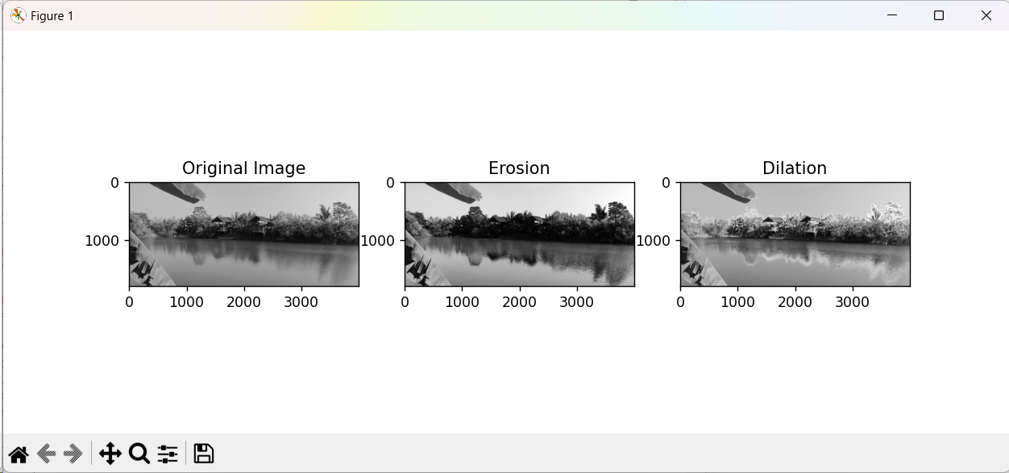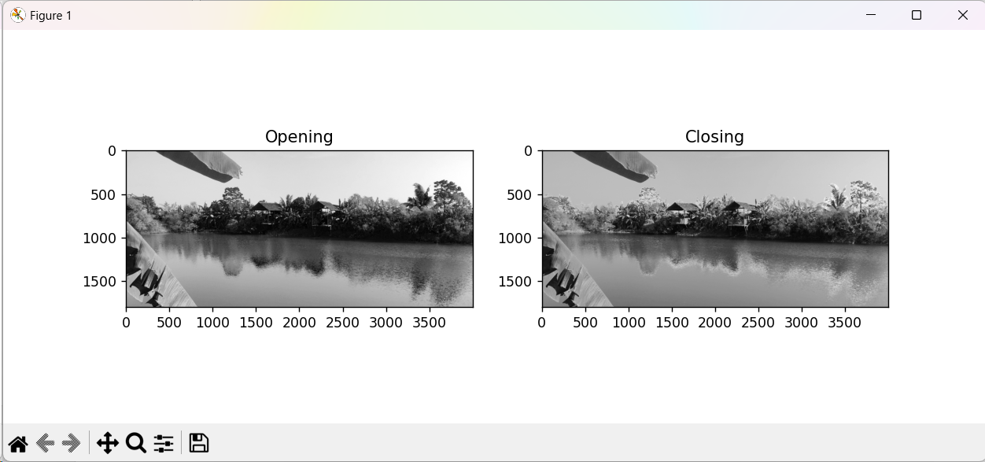

**practical 10:**

**Write the program to extract image features by implementing methods like corner and blob detectors, HoG and Haar feature**

Code:

import cv2

import numpy as np

from skimage import feature

import matplotlib.pyplot as plt

def corner_and_blob_detection(image_path):

# Read the image

image = cv2.imread(image_path)

gray = cv2.cvtColor(image, cv2.COLOR_BGR2GRAY)

# Corner Detection using Shi-Tomasi corner detector

corners = cv2.goodFeaturesToTrack(gray, maxCorners=100, qualityLevel=0.01, minDistance=10)

corners = np.int0(corners)

# Draw detected corners on the image

corner_img = image.copy()

for corner in corners:

x, y = corner.ravel()

cv2.circle(corner_img, (x, y), 3, 255, -1)

# Blob Detection using SimpleBlobDetector

params = cv2.SimpleBlobDetector_Params()

detector = cv2.SimpleBlobDetector_create(params)

keypoints = detector.detect(gray)

# Draw detected blobs on the image

blob_img = image.copy()

blob_img = cv2.drawKeypoints(blob_img, keypoints, np.array([]), (0, 0, 255), cv2.DRAW_MATCHES_FLAGS_DRAW_RICH_KEYPOINTS)

# Display images with detected corners and blobs

plt.figure(figsize=(12, 4))

plt.subplot(131)

plt.imshow(cv2.cvtColor(image, cv2.COLOR_BGR2RGB))

plt.title('Original Image')

plt.subplot(132)

plt.imshow(cv2.cvtColor(corner_img, cv2.COLOR_BGR2RGB))

plt.title('Corner Detection')

plt.subplot(133)

plt.imshow(cv2.cvtColor(blob_img, cv2.COLOR_BGR2RGB))

plt.title('Blob Detection')

plt.show()

def hog_feature_extraction(image_path):

# Read the image

image = cv2.imread(image_path)

gray = cv2.cvtColor(image, cv2.COLOR_BGR2GRAY)

# Compute HoG features

hog_features, hog_image = feature.hog(gray, visualize=True, block_norm='L2-Hys')

# Display the original image and HoG features

plt.figure(figsize=(10, 5))

plt.subplot(121)

plt.imshow(cv2.cvtColor(image, cv2.COLOR_BGR2RGB))

plt.title('Original Image')

plt.subplot(122)

plt.imshow(hog_image, cmap='gray')

plt.title('HoG Features')

plt.show()

def main():

image_path = "C:\PALLAVI WORK\MSC CS PART 1 IMAGE PROCESSING\practicals\sample.jpg"

# Corner and Blob Detection

corner_and_blob_detection(image_path)

# HoG Feature Extraction

hog_feature_extraction(image_path)

if __name__ == "__main__":

main()

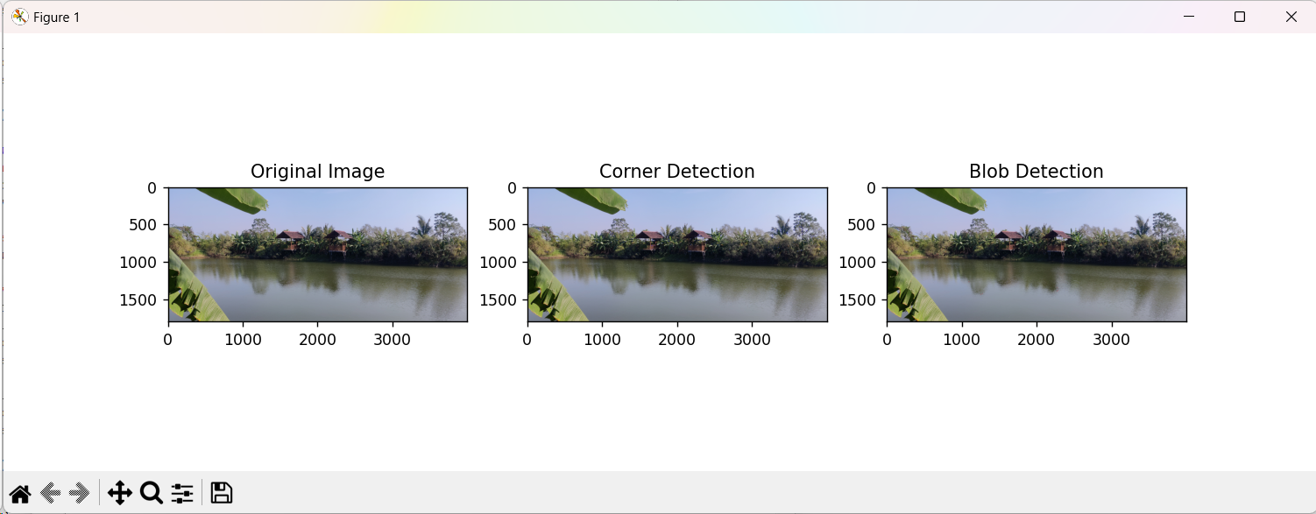

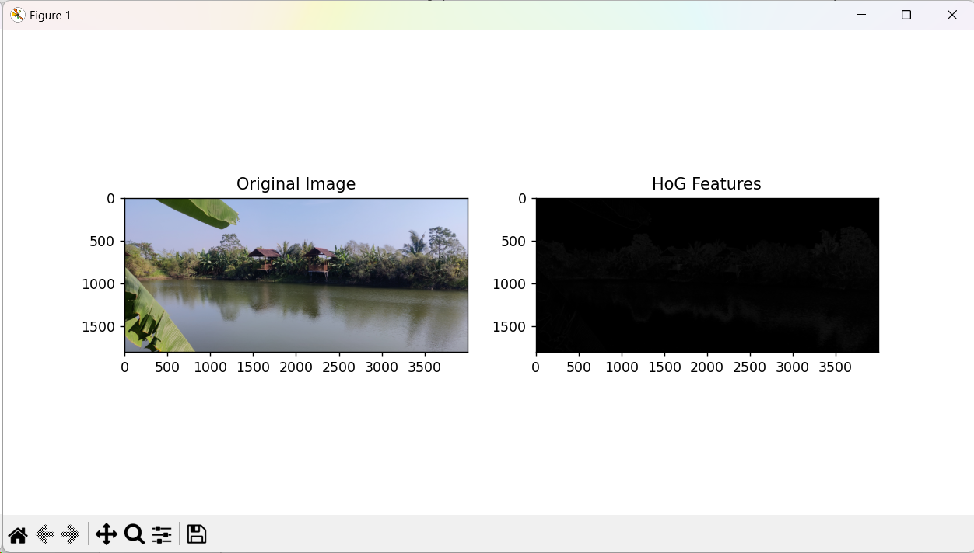

**Practical 11:**

**Write the program to apply segmentation for detecting lines, circles, and other shapes/ objects. Also, implement edge-based and region-based segmentation.**

Code:

import cv2

import numpy as np

import matplotlib.pyplot as plt

def edge_based_segmentation(image_path):

# Read the image

image = cv2.imread(image_path)

gray = cv2.cvtColor(image, cv2.COLOR_BGR2GRAY)

# Apply Canny edge detection

edges = cv2.Canny(gray, 50, 150)

# Display the original image and edges

plt.figure(figsize=(10, 4))

plt.subplot(121)

plt.imshow(cv2.cvtColor(image, cv2.COLOR_BGR2RGB))

plt.title('Original Image')

plt.subplot(122)

plt.imshow(edges, cmap='gray')

plt.title('Edge-based Segmentation')

plt.show()

def region_based_segmentation(image_path):

# Read the image

image = cv2.imread(image_path)

gray = cv2.cvtColor(image, cv2.COLOR_BGR2GRAY)

# Apply Gaussian blur to reduce noise

blurred = cv2.GaussianBlur(gray, (5, 5), 0)

# Apply adaptive thresholding for region-based segmentation

_, thresh = cv2.threshold(blurred, 127, 255, cv2.ADAPTIVE_THRESH_MEAN_C)

# Display the original image and region-based segmentation result

plt.figure(figsize=(10, 4))

plt.subplot(121)

plt.imshow(cv2.cvtColor(image, cv2.COLOR_BGR2RGB))

plt.title('Original Image')

plt.subplot(122)

plt.imshow(thresh, cmap='gray')

plt.title('Region-based Segmentation')

plt.show()

def shape_detection(image_path):

# Read the image

image = cv2.imread(image_path)

gray = cv2.cvtColor(image, cv2.COLOR_BGR2GRAY)

# Apply HoughLinesP for line detection

lines = cv2.HoughLinesP(gray, 1, np.pi / 180, threshold=50, minLineLength=50, maxLineGap=5)

# Draw detected lines on the image

line_img = image.copy()

for line in lines:

x1, y1, x2, y2 = line[0]

cv2.line(line_img, (x1, y1), (x2, y2), (0, 0, 255), 2)

# Apply HoughCircles for circle detection

circles = cv2.HoughCircles(gray, cv2.HOUGH_GRADIENT, dp=1, minDist=20, param1=50, param2=30, minRadius=5, maxRadius=50)

# Draw detected circles on the image

circle_img = image.copy()

if circles is not None:

circles = np.uint16(np.around(circles))

for i in circles[0, :]:

cv2.circle(circle_img, (i[0], i[1]), i[2], (0, 255, 0), 2)

# Display images with detected lines and circles

plt.figure(figsize=(12, 4))

plt.subplot(131)

plt.imshow(cv2.cvtColor(image, cv2.COLOR_BGR2RGB))

plt.title('Original Image')

plt.subplot(132)

plt.imshow(cv2.cvtColor(line_img, cv2.COLOR_BGR2RGB))

plt.title('Line Detection')

plt.subplot(133)

plt.imshow(cv2.cvtColor(circle_img, cv2.COLOR_BGR2RGB))

plt.title('Circle Detection')

plt.show()

def main():

image_path = "C:\PALLAVI WORK\MSC CS PART 1 IMAGE PROCESSING\practicals\sample.jpg"

# Edge-based Segmentation

edge_based_segmentation(image_path)

# Region-based Segmentation

region_based_segmentation(image_path)

# Shape Detection (Lines and Circles)

shape_detection(image_path)

if __name__ == "__main__":

main()

